**Assignment 1: Setting up Terraform Remote Backend**

* First we will create the manual instances in Azure Portal.
* Resource Group Creation:-

1. Login the Azure Portal and Create a Resource Group
2. Type Resource Group in Search Bar.
3. Go to Create Tab.
4. Fill all the details RG Name and Location.
5. Review + Create then Create
6. Search the Created RG in RG list.

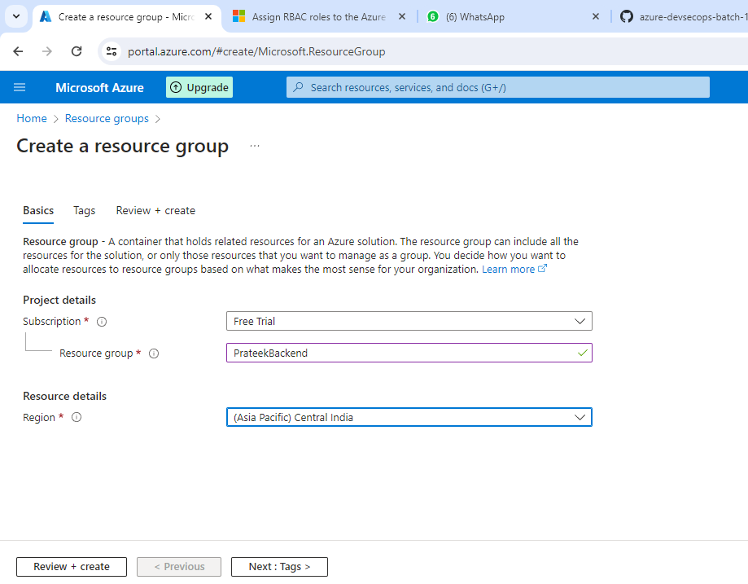

* Storage Account Creation:-

1. Search the storage account in search bar.
2. Select the storage account tab.
3. Go to create
4. Fill all the details like RG name in which you want to create SA.
5. SA name/Performance(Standard)/Redundancy(LRS)
6. Review + Create then Create.

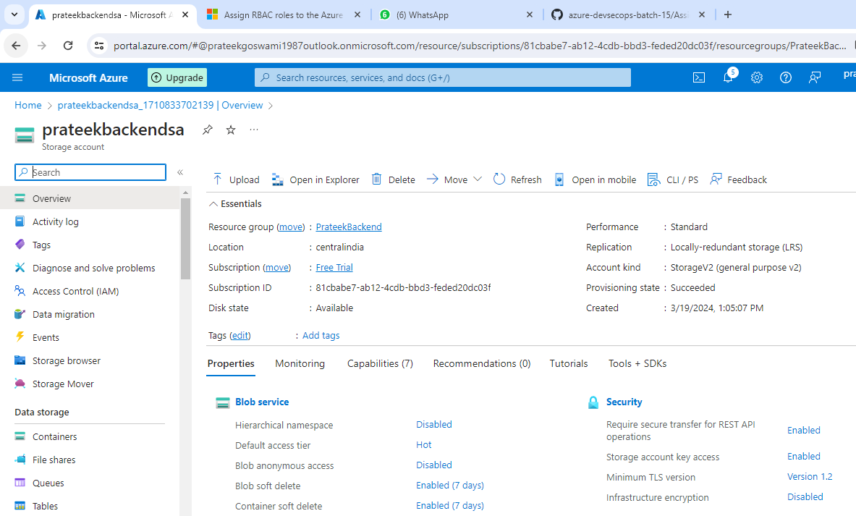

* Container Creation:-

1. Go to Storage Account.
2. Select the Container from the left hand tab.
3. Select container from the top bar.
4. Fill the details i.g name
5. Create.

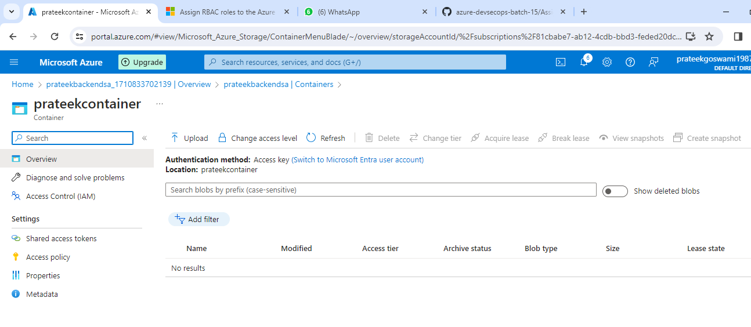

* Create instances using terraform.
* Create Storage Account:-

1. Copy the code of storage account from google.
2. Write the code in VScode.
3. Fill all the required details
4. SA name/RG name/Location/Account replication

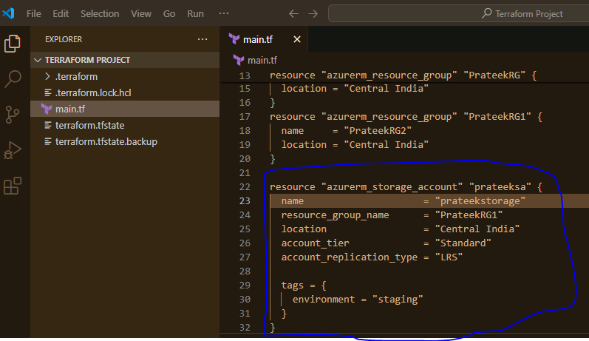

* Terraform validate:-

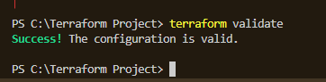

* Terraform Plan:-

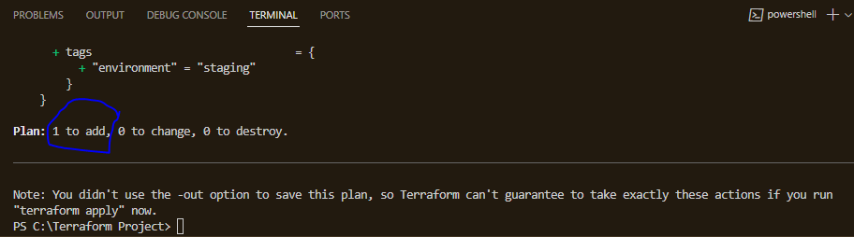

* Terraform apply:-

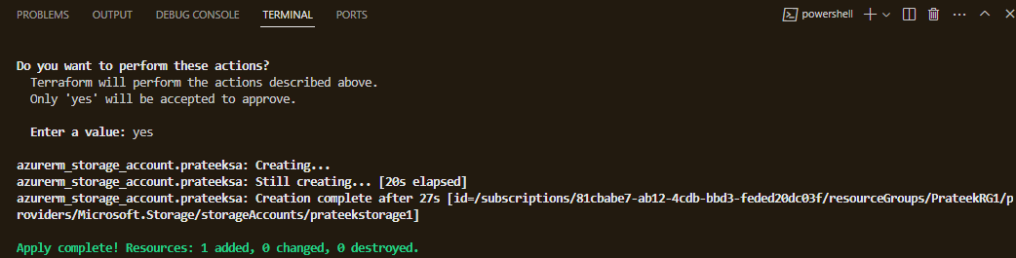

* Verify the storage account:-

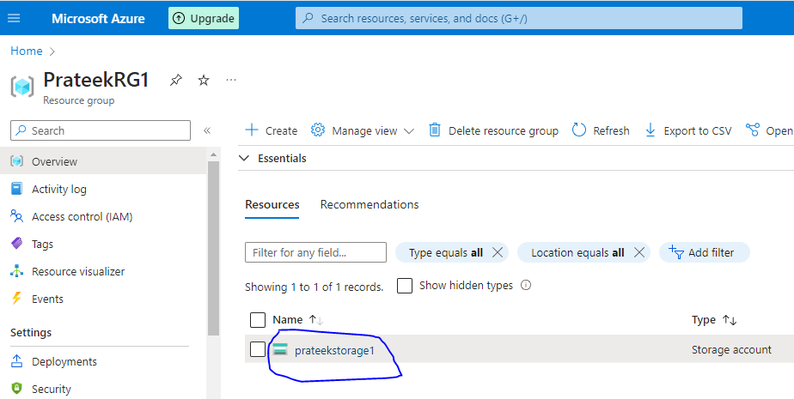

* Create the Container:-

1. Go to google and search create a container in azure using terraform
2. Pick the code from there.
3. Write the code in Vscode
4. Fill the details.

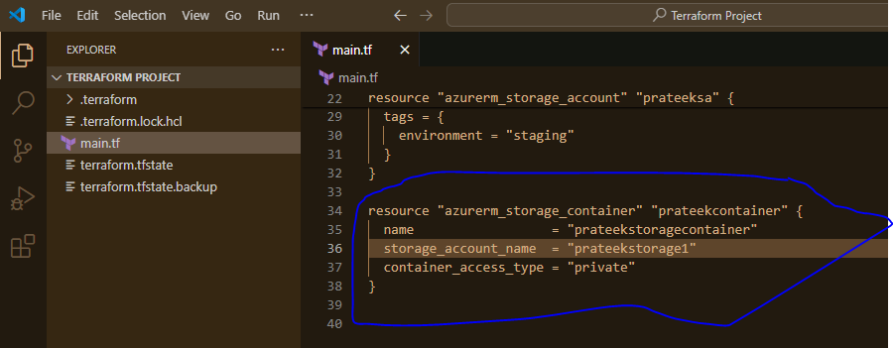

* Terraform Validate and Plan:-

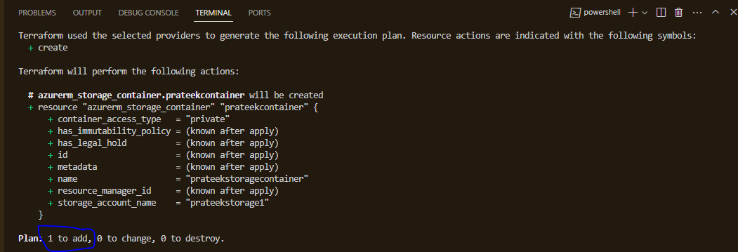

* Terraform apply:-

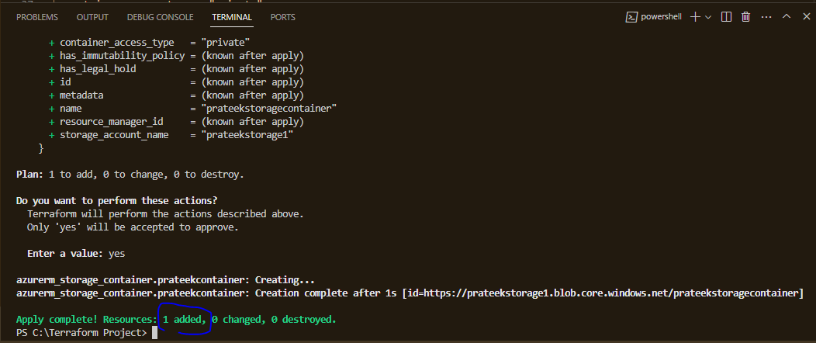

* Verify the container:-

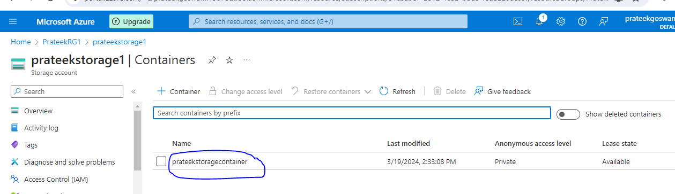

* Upload the state file on remote system:-

1. Go to google and search backend block in azure.
2. Write the code in VScode.
3. Change the names as required.
4. Run the command
5. Terraform init (we will run bcoz we did change in provider block)
6. Terraform validate/Plan/Apply

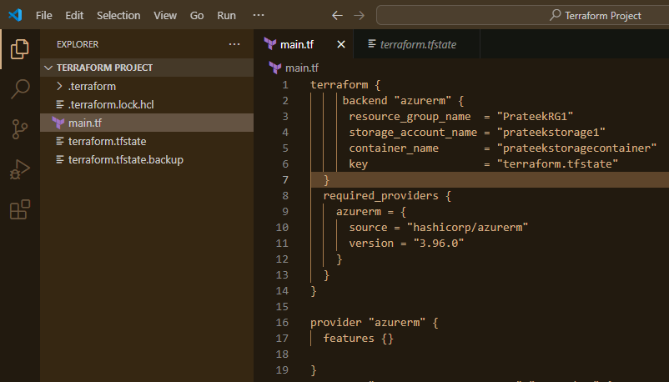

* Verify the state file in container:-

